- \Operation\Monitoring, main flap top\Monitoring, main flap top
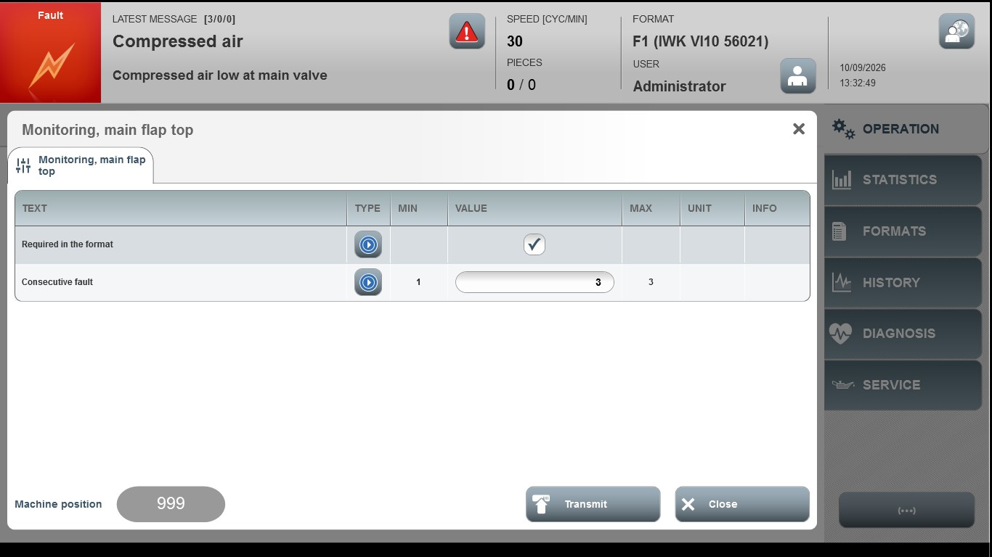
Acceptance criterion | Limits | Pass / Fail: Dev-No. | Date | Initials
Screen matches screenshot | N / A
Consecutive fault | 1…3

